Project Planning Phase
Project Planning Template (Product Backlog, Sprint Planning, Stories, Story Points)

Date | 29 September 2026
Project Name | Metro Ticket Generating System in ServiceNow
Maximum Marks | 5 Marks

Product Backlog, Sprint Schedule, and Estimation

Sprint | Functional Requirement (Epic) | User Story Number | User Story / Task | Story Points | Priority | Team Members
Sprint-1 | Catalog & Form Setup | USN-1 | Create Metro Ticket Catalog Item | 3 | High | Project Team
Sprint-1 | Catalog & Form Setup | USN-2 | Configure Source, Destination, Passenger Type and Ticket Count variables | 3 | High | Project Team
Sprint-1 | Catalog & Form Setup | USN-3 | Configure UI Policies / basic Catalog Client Scripts | 3 | High | Project Team
Sprint-2 | Fare Logic, Flow & Data | USN-4 | Implement fare and station mapping logic | 5 | High | Project Team
Sprint-2 | Fare Logic, Flow & Data | USN-5 | Build Flow Designer automation | 5 | High | Project Team
Sprint-2 | Fare Logic, Flow & Data | USN-6 | Create Metro Database custom table and variable mapping | 3 | High | Project Team
Sprint-2 | Fare Logic, Flow & Data | USN-7 | Create / maintain Request and RITM processing | 2 | Medium | Project Team
Sprint-3 | QR, Portal & Access | USN-8 | Implement QR-based digital ticket | 5 | High | Project Team
Sprint-3 | QR, Portal & Access | USN-9 | Implement Service Portal widget / spModal ticket display | 3 | High | Project Team
Sprint-3 | QR, Portal & Access | USN-10 | Configure request tracking and ticket visibility | 2 | Medium | Project Team
Sprint-3 | QR, Portal & Access | USN-11 | Configure roles and ACL access | 3 | High | Project Team
Sprint-4 | Testing, Debugging & Deployment | USN-12 | Test fare calculations and variable-to-field mappings | 3 | High | Project Team
Sprint-4 | Testing, Debugging & Deployment | USN-13 | Use Flow Execution Details to debug workflow failures | 2 | Medium | Project Team
Sprint-4 | Testing, Debugging & Deployment | USN-14 | Perform QR / portal compatibility testing | 3 | High | Project Team
Sprint-4 | Testing, Debugging & Deployment | USN-15 | Perform UAT and role/security testing | 3 | High | Project Team
Sprint-4 | Testing, Debugging & Deployment | USN-16 | Prepare deployment / recreation documentation for a new PDI | 5 | High | Project Team

Project Tracker, Velocity & Burndown Chart

Sprint | Total Story Points | Duration | Sprint Start | Sprint End (Planned) | Story Points Completed | Release Status
Sprint-1 | 9 | 5 Days | Day 1 | Day 5 | 9 | Completed
Sprint-2 | 15 | 5 Days | Day 6 | Day 10 | 15 | Completed
Sprint-3 | 13 | 5 Days | Day 11 | Day 15 | 13 | Completed
Sprint-4 | 16 | 5 Days | Day 16 | Day 20 | 16 | Completed

Velocity

Total completed story points = 53. Number of sprints = 4. Average team velocity = 53 / 4 = 13.25 story points per sprint.

Burndown Chart
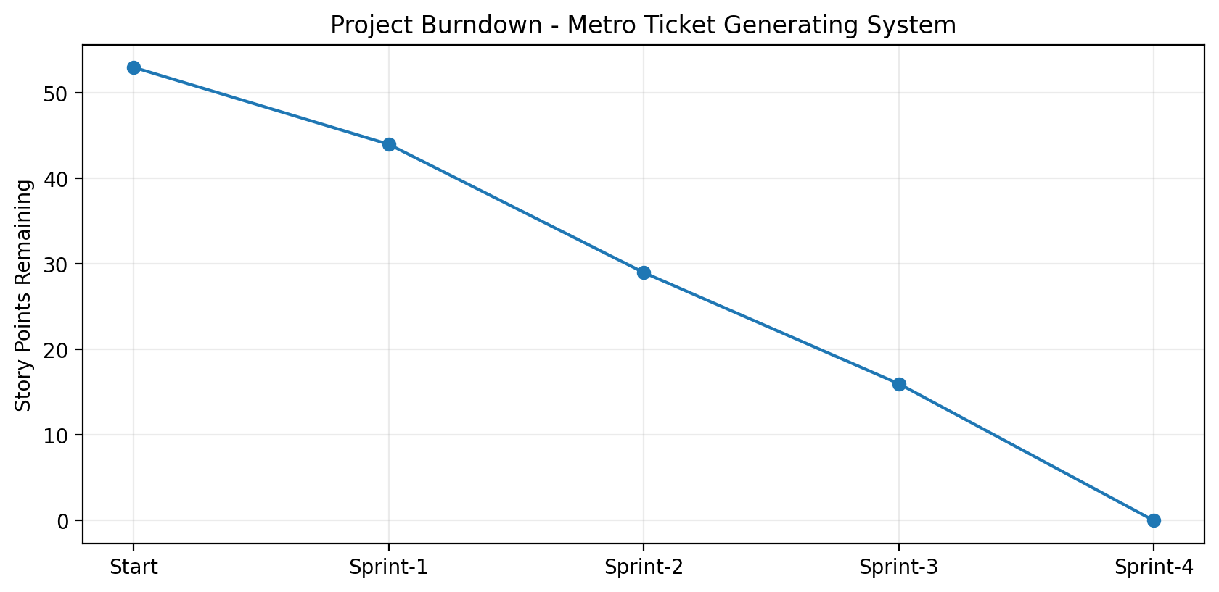
The burndown chart shows the remaining story points after each completed sprint. Because the project material did not provide exact historical calendar dates, the tracker uses a relative 20-day schedule (four 5-day sprints) while preserving the sprint sequence and completed work structure.

Sprint Release Summary

Sprint | Release Outcome
Sprint-1 | Catalog item and booking-form foundation completed.
Sprint-2 | Fare logic, Flow Designer, RITM/request processing, and Metro Database mapping completed.
Sprint-3 | QR ticket, Service Portal display, request visibility, roles and ACL configuration completed.
Sprint-4 | Fare/variable debugging, flow diagnostics, QR testing, UAT, security testing, and deployment documentation completed.

